1 Go into the my-first website folder and open the about-me.html file
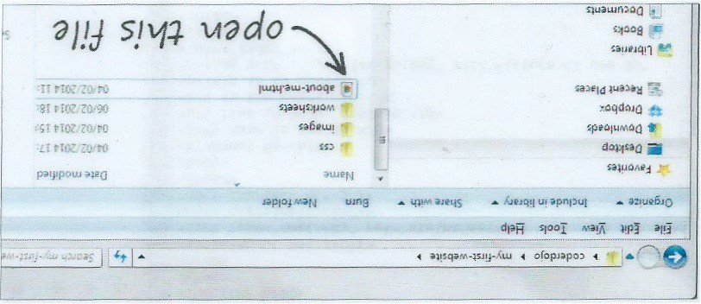

It opens in your web browser
2 Now open the same file in a plain text editor such as Notepad
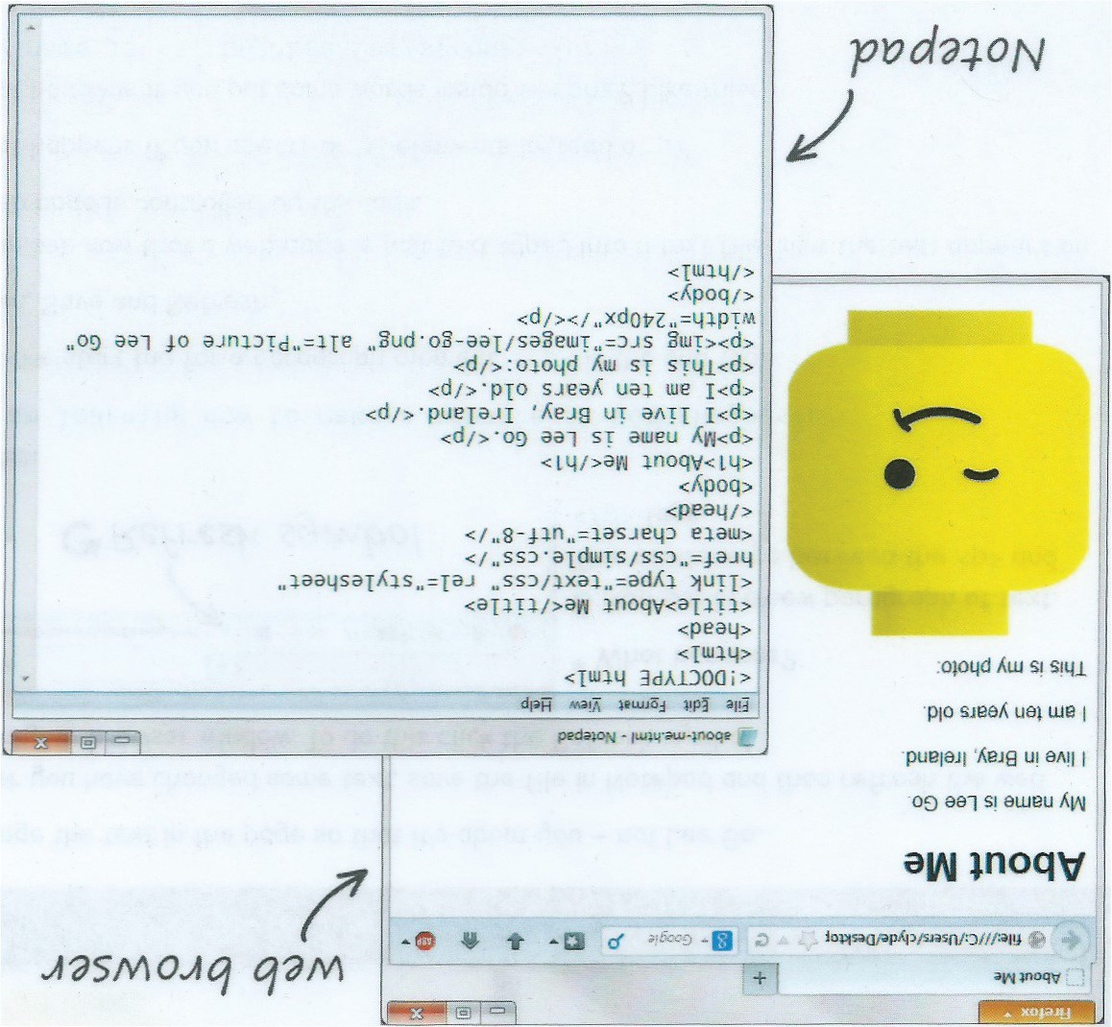
3 Next section with bold text
Sample Text Box – drag this around

4 Next section with bold text

Sushi Code

<a target="_blank" href="test.php">Proceed</a>;

Sushi Command

$ sudo apt-get install xrdp

